EXP NO 3:
CREATE A SIMPLE CLOUD SOFTWARE APPLICATION FOR PROPERTY BUYING & RENTAL PROCESS (IN CHENNAI CITY) USING ANY CLOUD SERVICE PROVIDER TO DEMONSTRATE SAAS.

AIM: To Create a simple cloud software application for Property Buying & Rental process (In Chennai city) using any Cloud Service Provider to demonstrate SaaS.
procedure:
step1: go to zoho.com
step 2: login to the zoho.com
step 3: select one application
step 4: enter application name
step 5: created new application
step 6: select one form
step 7: the software has been created.
Output
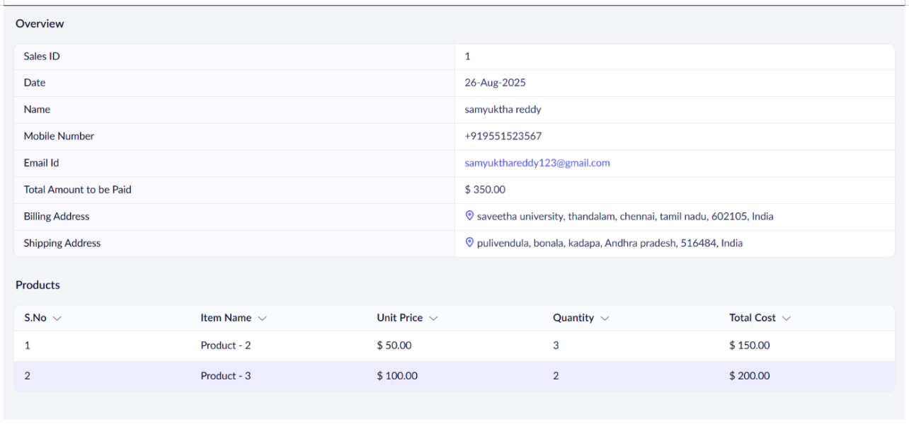

RESULT:
Successfully created a simple cloud software application and provide it as a service using any cloud service provider to demonstrate software as a service (SaaS).

